Application No...………………
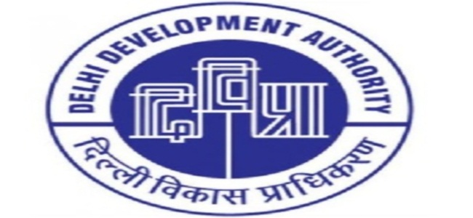
DELHI DEVELOPMENT AUTHORITY
DWARKA SPORTS COMPLEX

Attach coloured Passport Size photograph
SECTOR 11 DWARKA NEW DELHI-110075
SR. CITIZEN MEMBERSHIP APPLICATION FORM
FOR OFFICE USE:-
Membership No.

Date of Membership / /
_______________________________________________________________________________________________

- Name (in Block Letters)
- Father’s/ Husband’s Name
- Residential Address
PIN
- Office Address
PIN

- Mobile No.
(Mandatory)
- Email ID
(Mandatory)

- Occupation S-Service, B-Business, P-Profession, O-Others

- Details of Occupation

- Date of Birth

- Gender M-Male, F-Female, O- Any Other Category

- Marital Status S-Single, M-Married

- Nationality I-Indian, F-Foreign

- Educational Qualification 1. HSS, 2.Graduate, 3. Post Graduate, 4.Technical Graduate 5. Others

- Details of Dependants (including spouse)* who are to be enrolled.

Name
Attach Photo

Attach Photo

Attach Photo

Relation Date of Birth

Name

Relation Date of Birth

Name

Relation Date of Birth

Name
Attach Photo

Relation Date of Birth

- S-Son, D-Daughter, W-Wife, H-Husband
Note: -Document Required Prior Allotment of Membership.
- Residence/ ID Proof.
- Children between 5 to 21 years can be dependent members.
- Please attach Two passport size Photographs of Member and dependent
- Subscription fee is Rs. 90/-for the member and Rs. 70/- for spouse (Rs.40/- if spouse is also a Sr. Citizen) per month.

- I enclose here with Cash/Demand Draft No…………………….………..…dated…………….…………….……. drawn on …………………………………………………………………in favour of “CAU SPORTS, DDA ”for an amount of Rs………………(Rupees…………………………………………………………………………………………………..only)
(This is applicable when not paying by Debit / Credit Card)

- Undertaking

- All information furnished above are correct. However, my application form is liable to be rejected if details found to be incorrect.
- I have read the Rules and Regulation Bye-laws contained in the brochure of Dwarka Sports Complex and undertake to abide by the same.

Date………………………. (Signature of Applicant)

---------------------------------------------------------------------------------------------------------------------------------------------------------------------------------
FOR OFFICE USE ONLY: - ACKNOWLEDGEMENT Application No. ……………………
DELHI DEVELOPMENT AUTHORITY
DWARKA SPORTS COMPLEX, NEW DELHI

Received from Mr./Ms./Mrs…………………………………………………Application for Sr. Citizen membership of DSC and an amount of Rs……………(Rupees……………………………………………………………………………..only) in the form of Demand Draft No……………….Dt……………….Drawn on…………………..…….in favour of ‘’CAU SPORTS, DDA ’’ or through Debit or Credit Card.

Date…………….. (Signature of the Receiving Clerk with Stamp)

GUIDELINES OF SR. CITIZEN MEMBERSHIP
FOR DWARKA SPORTS COMPLEX

- Only one application should be submitted by an individual.
- Filled in downloaded application forms should be submitted at Admin Block Reception during working hours (10:00 a.m to 3.00 p.m) except lunch hours from 01:30 to 02:00p.mat the complex.
- Membership will be allotted after approval.
- Approved list of membership will be displayed on the notice board.
- Candidate will be required to deposit Entry Fee of Rs. 3,000 + GST (Non-refundable). Pay Order/Demand Draft should be drawn in favour of “CAU SPORTS, DDA”; or pay through Credit or Debit Card.
- Documents required to be submitted by the Candidates:-
- Residence/ ID Proof.
- Children between 5 to 21 years can be dependent members.
- Please attach Two passport size Photographs of Member and dependent.
- Subscription fee is Rs. 90/-for the member and Rs.70/- for spouse (Rs.40/- if spouse is also a Sr. Citizen) per month.

